# SQL QUERIES

1. Total number of calls

select COUNT(id) as total_no_of_calls from Call_Center_Data

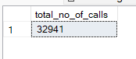

1. Call duration in minutes

select SUM(Call_Duration_In_Minutes) from Call_Center_Data



1. Call duration in hours

select SUM(Call_Duration_In_Minutes)/60 from Call_Center_Data

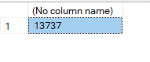

1. Average call duration

select CAST(AVG(Call_Duration_In_Minutes) as decimal(10,2)) as Average_Call_Duration from Call_Center_Data



1. Total no of calls per day

select DATENAME(DW,Call_Timestamp) as Call_Date, COUNT(DISTINCT id) as Total_Calls from Call_Center_Data group by DATENAME(DW,Call_Timestamp)

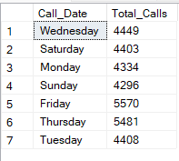

1. Total no of calls by state

select distinct(State), count(distinct id) as Total_Calls from Call_Center_Data group by State order by Total_Calls DESC

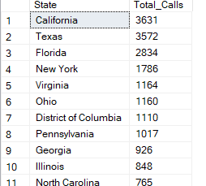

1. Reasons for calls

select distinct(Reason), count(distinct id) as Total_Calls from Call_Center_Data group by Reason

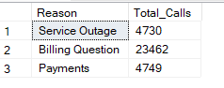

1. Total no of calls by channels

select distinct(Channel) as Total_Calls, count(distinct id) from Call_Center_Data group by Channel

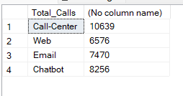

1. Total no of calls by Sentiment
2. select distinct(Sentiment) , count(distinct id) as Total_Calls from Call_Center_Data group by Sentiment

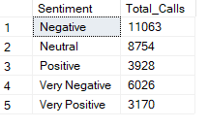

1. Total no of calls by call centre city
2. select distinct(Call_Centres_City) , count(distinct id) as Total_Calls from Call_Center_Data group by Call_Centres_City

